EXP1

Q1.

clc;

clear all;

close all;

I=imread('C:\Users\admin\Documents\3021167 Shreyas Patil\Sample images\rose.tif');

[r,c]=size(I)

imshow(I)

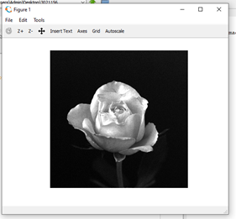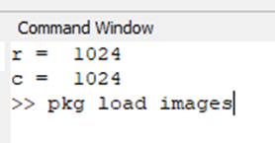

Q2. clc;

clear all;

close all;

I=imread('C:\Users\admin\Documents\3021167 Shreyas Patil\Sample images\rose.tif');

[r,c]=size(I)

imshow(I)

J=I(1;10,1;10)

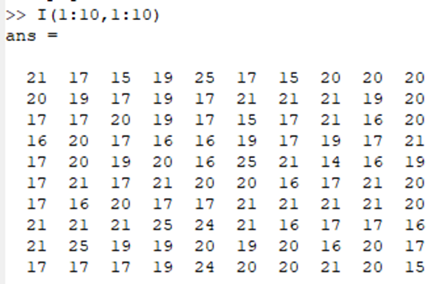

Q3. . clc;

clear all;

close all;

I=imread('C:\Users\admin\Documents\3021167 Shreyas Patil\Sample images\rose.tif');

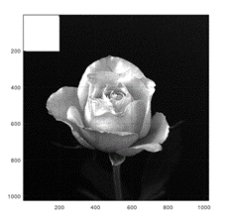[r,c]=size(I)

imshow(I)

J= I(1:10,1:10)

for i=1:200

for j=1:200

I(i,j)=255;

endfor

endfor

imshow(I)

Q4. clc;

clear all;

close all;

I=imread('C:\Users\admin\Documents\3021167 Shreyas Patil\Sample images\rose.tif');

[r,c]=size(I)

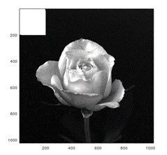imshow(I)

J= I(1:10,1:10)

for i=1:200

for j=1:200

I(i,j)=256;

endfor

endfor

imshow(I)

Q5. clc;

clear all;

close all;

I=imread('C:\Users\admin\Documents\3021167 Shreyas Patil\Sample images\rose.tif');

[r,c]=size(I)

imshow(I)

J= I(1:10,1:10)

for i=1:200

for j=1:200

I(i,j)=256;

endfor

endfor

imshow(I)

I=imread('C:\Users\admin\Documents\3021167 Shreyas Patil\Sample images\rose.tif');

figure;

subplot(1,2,1)

imshow(I)

for i=1:r

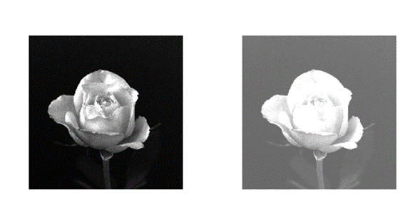 for j=1:c

I(i,j)=I(i,j)+100;

endfor

endfor

subplot(1,2,2)

imshow(I)

Q6.1 clc;

clear all;

close all;

I=imread('C:\Users\admin\Documents\3021167 Shreyas Patil\Sample images\rose.tif');

[r,c]=size(I)

imshow(I)

J= I(1:10,1:10)

for i=1:200

for j=1:200

I(i,j)=256;

endfor

endfor

imshow(I)

I=imread('C:\Users\admin\Documents\3021167 Shreyas Patil\Sample images\rose.tif');

figure;

subplot(1,2,1)

imshow(I)

for i=1:r

for j=1:c

I(i,j)=I(i,j)+100;

endfor

endfor

subplot(1,2,2)

imshow(I)

J=zeros(r,c);

for i=300:700

for j=300:700

J(i,j)=255;

endfor

endfor

figure

imshow(J)

Q6.2

clc;

clear all;

close all;

I=imread('C:\Users\admin\Documents\3021167 Shreyas Patil\Sample images\rose.tif');

[r,c]=size(I)

imshow(I)

J= I(1:10,1:10)

for i=1:200

for j=1:200

I(i,j)=256;

endfor

endfor

imshow(I)

I=imread('C:\Users\admin\Documents\3021167 Shreyas Patil\Sample images\rose.tif');

figure;

subplot(1,2,1)

imshow(I)

for i=1:r

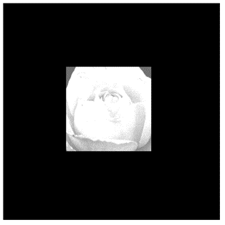 for j=1:c

I(i,j)=I(i,j)+100;

endfor

endfor

subplot(1,2,2)

imshow(I)

J=zeros(r,c);

for i=300:700

for j=300:700

J(i,j)=1;

endfor

endfor

figure

imshow(J);

K=I.*J;

figure

imshow(K);

Q7. clc;

clear all;

close all;

I=imread('C:\Users\admin\Documents\3021167 Shreyas Patil\Sample images\peppers.png');

R=I(:,:,1);

G=I(:,:,2);

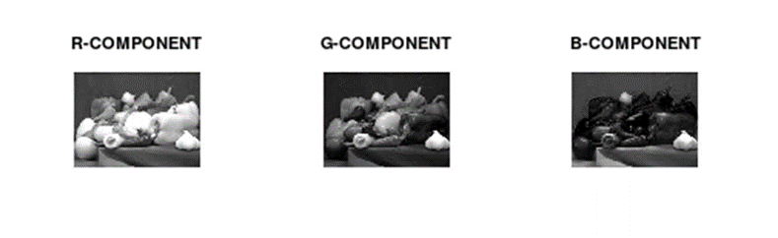B=I(:,:,3);

figure;

subplot(1,3,1)

imshow(R)

title('R component')

subplot(1,3,2)

imshow(G)

title('G component')

subplot(1,3,3)

imshow(B)

title('B component')

Q8. clc;

clear all;

close all;

I= imread('C:\Users\admin\Documents\3021167 Shreyas Patil\Sample images\peppers.png');

J= rgb2gray(I);

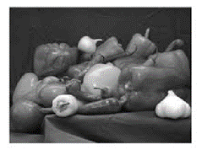size(I)

size(J)

imshow(J)

Q10.

clc;

clear all;

close all;

I=imread('C:\Users\admin\Documents\3021167 Shreyas Patil\Sample images\lena.tif');

[r,c]=size(I)

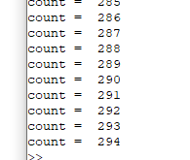test_level=45;

count=0

for i=1:r

for j=1:c

if I(i,j)==test_level

count=count+1

endif

endfor

endfor

Q.12

clc;

clear all;

close all;

I = imread('C:\Users\admin\Documents\3021167 Shreyas Patil\Sample images\lena.tif');

[r, c] = size(I);

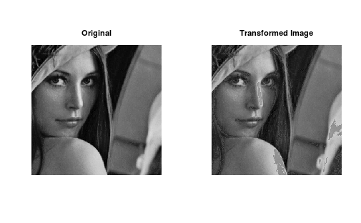subplot(1,2,1);

imshow(I);

title('Original');

for i = 1:r

for j = 1:c

if I(i,j) < 40

I(i,j) = 2 * I(i,j);

elseif I(i,j) > 200

I(i,j) = I(i,j) - 60;

end

end

end

subplot(1,2,2);

imshow(I);

title('Transformed Image');

Q 13.

clc;

clear all;

close all;

I = imread('C:\Users\admin\Documents\3021167 Shreyas Patil\Sample images\lena.tif');

[r, c] = size(I);

subplot(1,2,1);

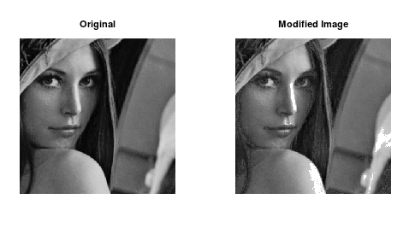imshow(I);

title('Original');

for i = 1:r

for j = 1:c

if I(i,j) < 40

I(i,j) = 2 * I(i,j);

elseif I(i,j) > 200

I(i,j) = 255 ;

end

end

end

subplot(1,2,2);

imshow(I);

title('Modified Image');

Q 11. clc;

clear all;

close all;

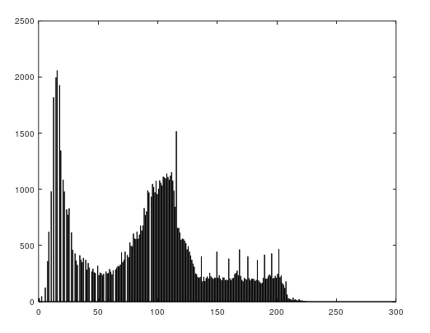I=imread('C:\Users\admin\Documents\3021167 Shreyas Patil\Sample images\lena.tif');

[r,c]=size(I)

count=zeros(256);

for i=1:r

for j=1:c

x=I(i,j)

count(x+1)=count(x+1)+1;

endfor

endfor

bar(count)